TEST REPORT

BUREAU

Technical Report : (6617)303-1342

DATE : November 3, 2017

PAGE : 1 OF 3

APPLICANT:

TIANJIN YIXIN PACK CO., LTD.

645KK97 AVIATION INDUSTRY CENTRE AIRPORT ECONOMIC ZONE TIANJIN CHINA.

Date of Submission: Test Period:

Sample Description: Test Item(s):

October 30, 2017

October 30, 2017 to November *3,* 2017

Sample(s) received is/are stated to be: A) PLASTIC TUBES Details see page 3

Color: /

Age Grade: /

Vendor: /

Manufacturer: /

End Buyer: /

Model No./ Style No⑻: PO No.: '

Supplier Reference: Country of Origin: Country of Destination:

China

Oversea Country

SUMMARY OF TEST RESULTS

|  |  |
| --- | --- |
| **TEST REQUESTED** | **CONCLUSION** |
| Olefin Polymers - Polyethylene - U.S. FDA 21 CFR 177.1520 | PASS |

Note: 1) The tested part of the sample was specified by client.

1. The test requested was specified by client.
2. The test conclusion was given based on the results of tested part.

REMARK

If there are questions or concerns on this report, please contact the following persons:

General enquiry and invoicing Technical enquiry

PREPARED BY :

Mr. Joy Li/ Ms. Joanna Chen (021)24166888*6833/6841

Jonny.Yin @cn .bureauveritas.com/ [Joan.Chen@cn.bureauveritas.com](mailto:Joan.Chen@cn.bureauveritas.com)

Mr. Paul Li

(021)24166857

Paul. Li@cn .bureauveritas .com

BUREAU VERITAS

CONSUMER PRODUCTS SERVICES DIVISION (SHANGHAI)

Paul Li

Technical Specialist

Bureau Veritas

Consumer Products Services Division (Shanghai) No. 168, Guanghua Road, Zhuanqiao Town, Minliang, Shanghai China, 201108 Tel.:86-21 -24081888 Fax:86-21 -64890042 Email: [bvcps_sh_info@cn.bureauveritas.com](mailto:bvcps_sh_info@cn.bureauveritas.com) Http:www. bureauventas.com/cps

This report is governed by, and mcOTporates by reference, die Conditions of Testing as posted at the date of issuance of diis report at

http://www.cps_bureauveitas.com and is mtended for your etdusive use. Any copying or rq)lication of this report to or for any other person or entity, or use of our name or trademaik, is permitted only with our prior written penmssion. This report sets forth our fiodmgs solely wiA reject to die test samples identified herein. The results set foriiin flus report axe not indicative or representative of flie quality or characteristics of the lot from which a test sample was taken or any similar or identical product unless specifically and expressly noted. Our report includes all of fee tests requested by yon and flie results diereof based iq>on flie mfonnation that you provided to us. You have 60 days &om date of issuance of flus report to notify us of any material error or omission caused by our negligoice; provide^ however, diat such notice shall be in writing and shall specifically address die issue you wish to raise. A failure to raise such issue wi£m tbe prescribed time shall constitute you unqualified acceptance of die oon^leleness of this report the tests conducted and the correctness of flie report contents.

Technical Report : (6617)303-1342

DATE : November 3, 2017 PAGE : 2 OF 3

BUREAU

**Photo of the Submitted Sample**

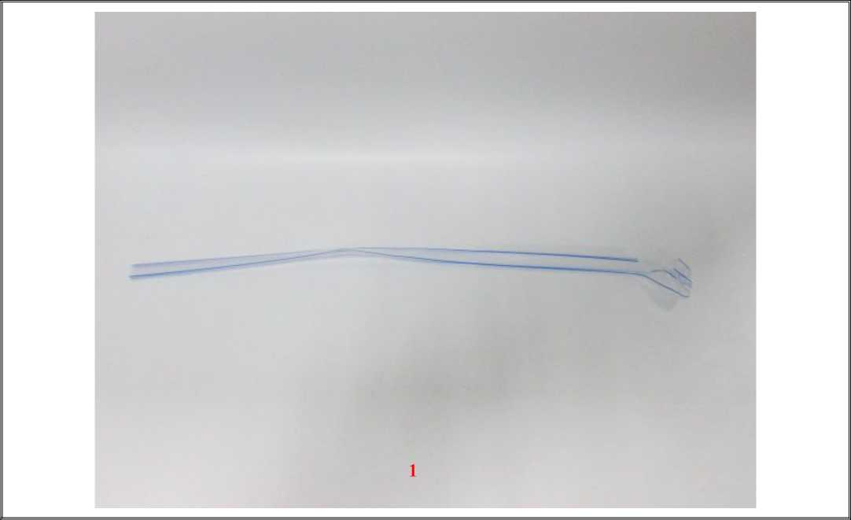

Technical Report DATE PAGE

(6617)303-1342 November 3, 2017 3 OF 3

**TEST RESULT**

Sample Description Assigned by Laboratory:

|  |  |  |
| --- | --- | --- |
| **Test Item** | **Description** | **Client Claimed Material** |
| 1 | Transparent and blue plastic | PE |

Olefin Polymers - Polyethylene - U.S. FDA 21 CFR 177.1520

For use in articles that contact food except for articles used for packing or holding food during cooking

|  |  |  |  |
| --- | --- | --- | --- |
| **Parameter** | **Unit** | **Result** | **Limit** |
| **1** |
| Density | g/cm3 | 0.877 | 0.85-1.00 |
| Total Extractives (n-Hexane) | % w/w | 0.9 | <5.5 |
| Total Extractives (Xylene) | % w/w | 1.4 | <11.3 |
| **Conclusion** | - | PASS | - |

Note: g/cm3 = gram per cubic centimetre

% w/w = percent weight by weight cc<,,= less than or equal to

Method: U.S. FDA 21 CFR 177.1520.

END